**Suggested Topics**

1. **Using sketches to make government more open: an alternative medium**
2. **Taking a step back: making open data more ethical**
3. **The use of creative methods to hold government accountable**

By: Faraz Ahmed

*Tags: Open Data, Freedom of Information Act, Ethical Usage of Data, Right to Privacy, Right to Information, Sketches*

Excerpt:

Tweets:

* [headline]?

*Featured picture:*

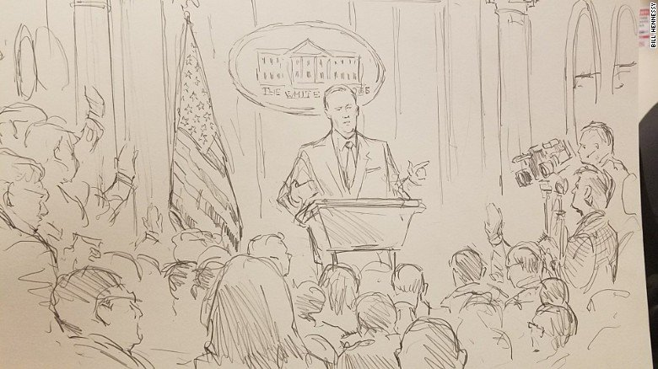

*Main body:*

Since taking Office, the Trump Administration has left no stone unturned to avoid its actions become more transparent. The decision to fire James Comey in May who was leading investigation on probable Russian intervention in the U.S. elections was a major impediment to make the government more accountable. Similarly, in April, under the direction of Trump, the White House stopped disclosing information on its visitor logs. (http://time.com/4740499/white-house-visitor-logs-public-record-trump/).

It was, therefore, not surprising when the communications team of the White House banned the use of cameras in the press briefing on Friday’s. CNN swiftly reacted to this and very cleverly sent Bill Hennesy to attend the press briefing and create a sketch of the scene. Bill Hennesy was the right person to do this. He has an admirable record of drawing artwork for the proceedings at the United State’s Supreme Court, which has characteristically assumed great control of what the reporters are and aren’t allowed to visually or audio-wise record. But to what extent can a sketch give us insights as to what is happening inside the government?

The sketch of the Friday’s briefing by Bill Hennesy shows a typical Sean Spicer with his aggressive demeanor standing behind the podium and next to a giant U.S. flag. His finger is pointed towards the next person he’s going to ask the question from. It also shows that the briefing attracted quite a number of reporters besides the designated camera person of the White House. While the sketch may not give us details on the conversation that was held, it still speaks a thousand words. In addition to that, it preserves the privacy of the people present in the room and prevents distraction that is much more pronounced in the clicks of the traditional flash photography.

Given that, one cannot help but ponder over the importance of sketches in the sphere of Open Data. With the spark that the Open Data Movement has generated recently, there are people who falsely think that it’s a recent phenomenon. But the illustration of court proceedings and press briefings show us that it is not. Sketches were a powerful way of getting a peek inside the court proceedings dated as early as 17th Century in the U.S. (cite), while preserving the privacy of both the defendants and prosecutors. Sketch artists such as George Caleb Bingham and David G. Blyth and more recently, Mona Shafer Edwards, made their mark through their skillful and speedy drawing of accurate or near accurate depictions of the drama, scenery and imagery inside the proceedings. But this would not last long. Over time, with the advent of modern photography, some court districts started allowing its use without distraction to make way for greater accountability. But did it achieve the purpose?

**--how the courtroom illustrations made open gov possible**

**--what impact had the illustrations had on the govt in general**

**--contrasting illustrations with modern tech w.r.t open government**

**--future of illustrations**

Ironically, as Open Data has expanded through the use of modern technology, the issue of ethics surrounding its use have also become salient. For example, after the deplorable Sandy Hook Elementary incident in Newtown, Connecticut in 2012, the city government permitted citizens to own a gun. The data on who possessed a weapon (obtained through the Freedom of Information Act) was then plotted on an interactive map of the city that revealed the addresses of such individuals. Through the map, one could identify not just the people who owned guns but also those who did not and were, therefore, vulnerable to crimes such as theft. This posits a direct conflict between the right to obtain information and the right to individual privacy (https://cis-india.org/internet-governance/blog/ethical-issues-in-open-data).

Moreover, in the struggle to make data more open, some people, sometimes inadvertently, put their lives at risks. Edward Snowden, the NSA whistleblower, hasn’t had a public life since 2013. This month, after serving seven years in prison and being charged with 22 offences, Chelsea Manning was declared by the Department of Defence not to be a threat to the United State’s interests. These are few of the many ethical issues that the Open Data community is grappling with.

These risks would likely be avoided should the government revert back to the old age practise of using sketches as the only medium of accountability. While not practically advisable given the pace at which technology is changing, it does leave us with a very important lesson: open data is important but all that glitters is not gold. Learning to draw the line between what to share and what not to share should be a priority of all the stakeholders pushing for greater transparency and accountability within the U.S. and across the world.

Extra/ignore:

"We're surrounded by 21st-century technology," Shafer Edwards says. "And here I come in, and I'm still necessary. I'm still relevant. And every year, I think this is the swan song, this is the end of my career. And then something happens, where a judge in his brilliance, or her brilliance, decide that they don't want the camera in there. Or the witnesses don't want to be photographed."